

实 验 报 告

课程名称： | 大学数学实验
学生姓名： | 陈梦泽
学生学号： | 202330842331
学生专业： | 金融科技
开课学期： | 2023-2024学年第2学期

- 实验目的
  - 了解回归分析的基本概念与原理，掌握Matlab实现方法
  - 学会用回归分析建模并解决实际问题
- 问题1
问题内容
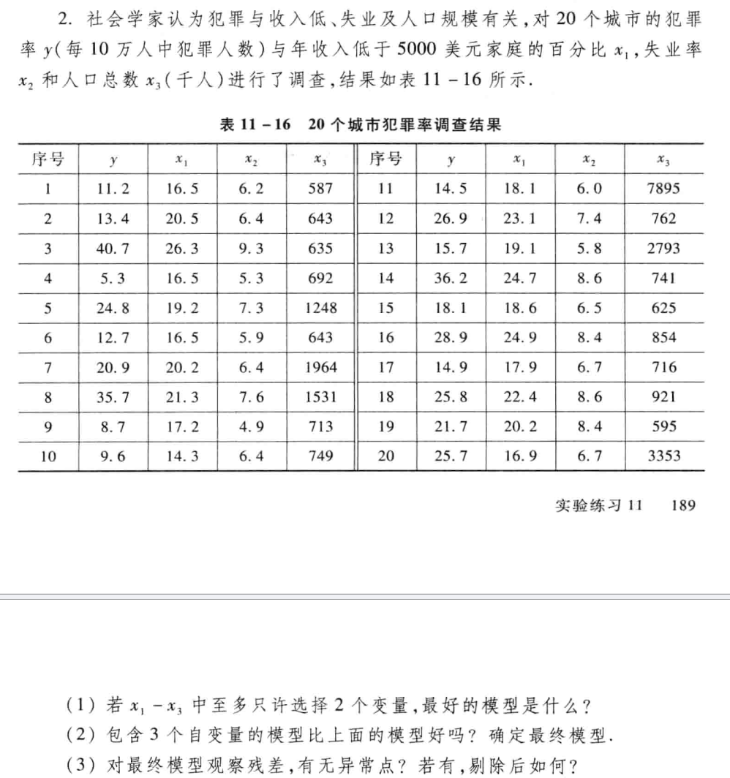
2.1.1算法和编程：
function A
y=[11.2 13.4 40.7 5.3 24.8 12.7 20.9 35.7 8.7 9.6 14.5 26.9 15.7 36.2 18.1 28.9 14.9 25.8 21.7 25.7]';
x1=[16.5 20.5 26.3 16.5 19.2 16.5 20.2 21.3 17.2 14.3 18.1 23.1 19.1 24.7 18.6 24.9 17.9 22.4 20.2 16.9]';
x2=[6.2 6.4 9.3 5.3 7.3 5.9 6.4 7.6 4.9 6.4 6.0 7.4 5.8 8.6 6.5 8.4 6.7 8.6 8.4 6.7]';
x3=[587 643 635 692 1248 643 1964 1531 713 749 7895 762 2793 741 625 854 716 921 595 3353]';

n=size(y,1); % 20
r1=corrcoef(y,x1);
r2=corrcoef(y,x2);
r3=corrcoef(y,x3);
disp(" ")
disp("r1~r3: "+r1(2,1)+" "+r2(2,1)+" "+r3(2,1)) % r1~r3: 0.83978 0.86412 -0.067098
disp("(1) choose x1,x2")
disp(" ")
x=[x1 x2 x3];

disp("(2) stepwise running...")
stepwise(x,y)
disp("(2) choose x1,x2")
disp("b: ")
X=[ones(n,1),x1,x2];
[b,bint,r,rint,stats]=regress(y,X);
disp(b)

disp("(3)")
plot(r,"+"),title("r,throw 8th and 20th")
disp("throw 2th and 19th")
disp("b: ")
x1=[x1(1:7);x1(9:19)];
x2=[x2(1:7);x2(9:19)];
y=[y(1:7);y(9:19)];
X=[ones(n-2,1),x1,x2];
[b,bint,r,rint,stats]=regress(y,X);
disp(b)
end

2.1.2运行结果：
>> A

r1~r3: 0.83978 0.86412 -0.067098
(1) choose x1,x2

(2) stepwise running...
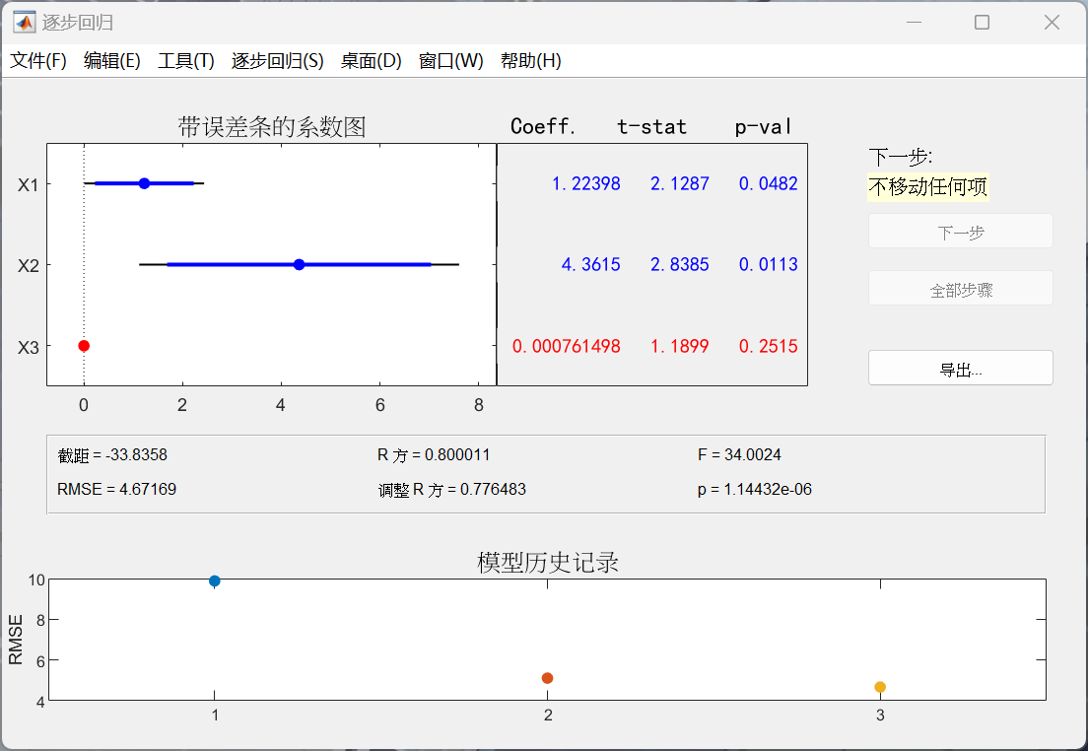
(2) choose x1,x2
b:
-33.8358
1.2240
4.3615

(3)
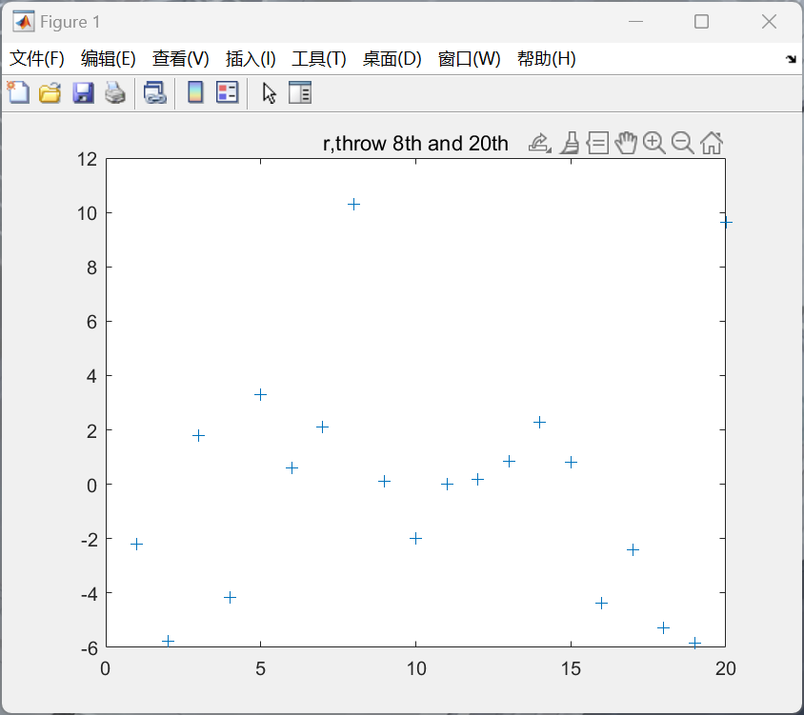
throw 2th and 19th
b:
-35.5229
1.6040
3.3581

问题2
问题内容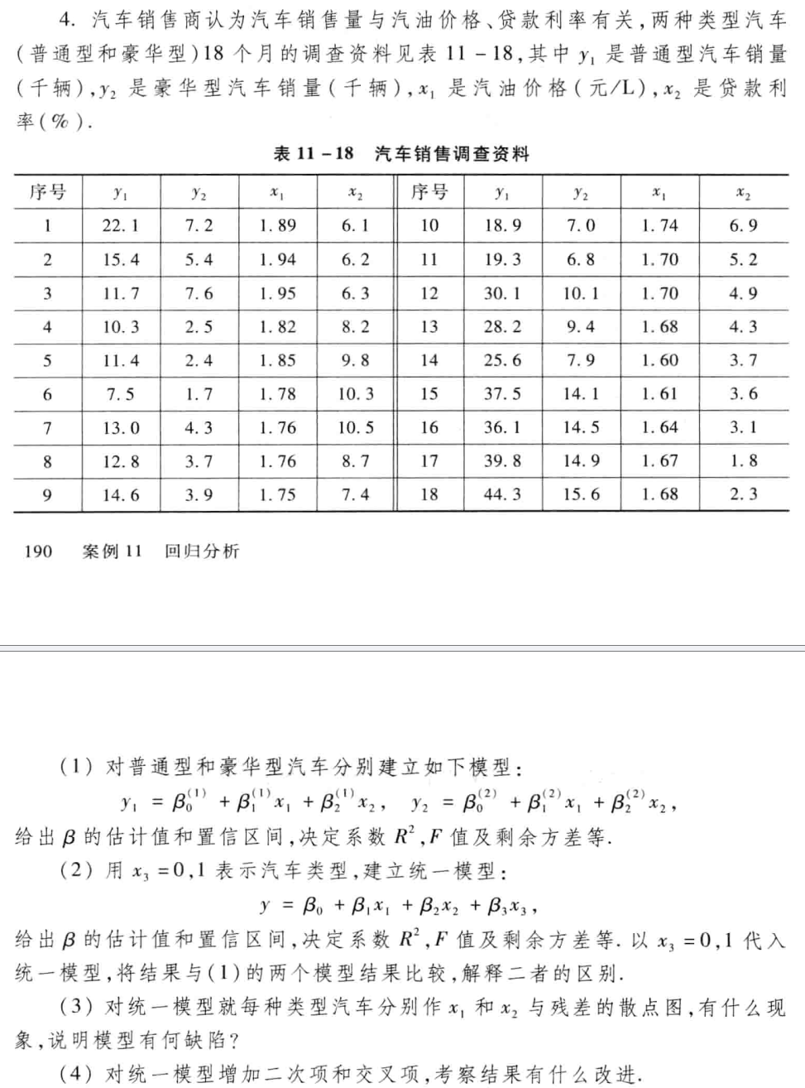
2.2.1算法和编程：
function B
y1=[22.1 15.4 11.7 10.3 11.4 7.5 13.0 12.8 14.6 18.9 19.3 30.1 28.2 25.6 37.5 36.1 39.8 44.3]';
y2=[7.2 5.4 7.6 2.5 2.4 1.7 4.3 3.7 3.9 7.0 6.8 10.1 9.4 7.9 14.1 14.5 14.9 15.6]';
x1=[1.89 1.94 1.95 1.82 1.85 1.78 1.76 1.76 1.75 1.74 1.70 1.70 1.68 1.60 1.61 1.64 1.67 1.68]';
x2=[6.1 6.2 6.3 8.2 9.8 10.3 10.5 8.7 7.4 6.9 5.2 4.9 4.3 3.7 3.6 3.1 1.8 2.3]';

n=size(y1,1); % 18
x=[x1 x2];
X=[ones(n,1) x];
disp("(1)")
disp("y1:")
disp(" ")
[b,bint,r,rint,stats]=regress(y1,X,.05);
disp("b & bint: ")
disp(" ")
disp(b)
disp(bint)
disp("R²: "+stats(1,1)+" F: "+stats(1,2)+" s²: "+stats(1,4))

disp("y2:")
disp(" ")
[b,bint,r,rint,stats]=regress(y2,X,.05);
disp("b & bint: ")
disp(" ")
disp(b)
disp(bint)
disp("R²: "+stats(1,1)+" F: "+stats(1,2)+" s²: "+stats(1,4))
disp(" ")

disp("(2)")
disp("y1: x3 = 0, y2: x3 = 1")
X1=[X zeros(n,1)];
X2=[X ones(n,1)];
y=[y1;y2];
[b,bint,r,rint,stats]=regress(y,[X1;X2],.05);
disp("b & bint: ")
disp(" ")
disp(b)
disp(bint)
disp("R²: "+stats(1,1)+" F: "+stats(1,2)+" s²: "+stats(1,4))

disp("(3)")
subplot(1,2,1),scatter([x1;x1],r)
subplot(1,2,2),scatter([x2;x2],r)
disp("different plots, consider interaction")

disp("(4)")
X=[X x2.^2 x1.^2 x1.*x2];
X1=[X zeros(n,1) zeros(n,1) zeros(n,1)];
X2=[X ones(n,1) x1 x2];
y=[y1;y2];
[b,bint,r,rint,stats]=regress(y,[X1;X2],.05);
disp("b & bint: ")
disp(" ")
disp(b)
disp(bint)
disp("R²: "+stats(1,1)+" F: "+stats(1,2)+" s²: "+stats(1,4))

2.2.2运行结果
>> B
(1)
y1:

b & bint:

90.1814
-27.6588
-3.2283

46.1971 134.1656
-54.5542 -0.7634
-4.2747 -2.1819

R²: 0.85929 F: 45.7992 s²: 20.791
y2:

b & bint:

24.5471
-4.6285
-1.4360

5.9201 43.1740
-16.0184 6.7615
-1.8792 -0.9929

R²: 0.84025 F: 39.4474 s²: 3.7288

(2)
y1: x3 = 0, y2: x3 = 1
b & bint:

64.5753
-16.1436
-2.3322
-14.4222

33.5007 95.6499
-35.1193 2.8320
-3.0705 -1.5939
-17.6546 -11.1898

R²: 0.8366 F: 54.6111 s²: 22.6642
(3)
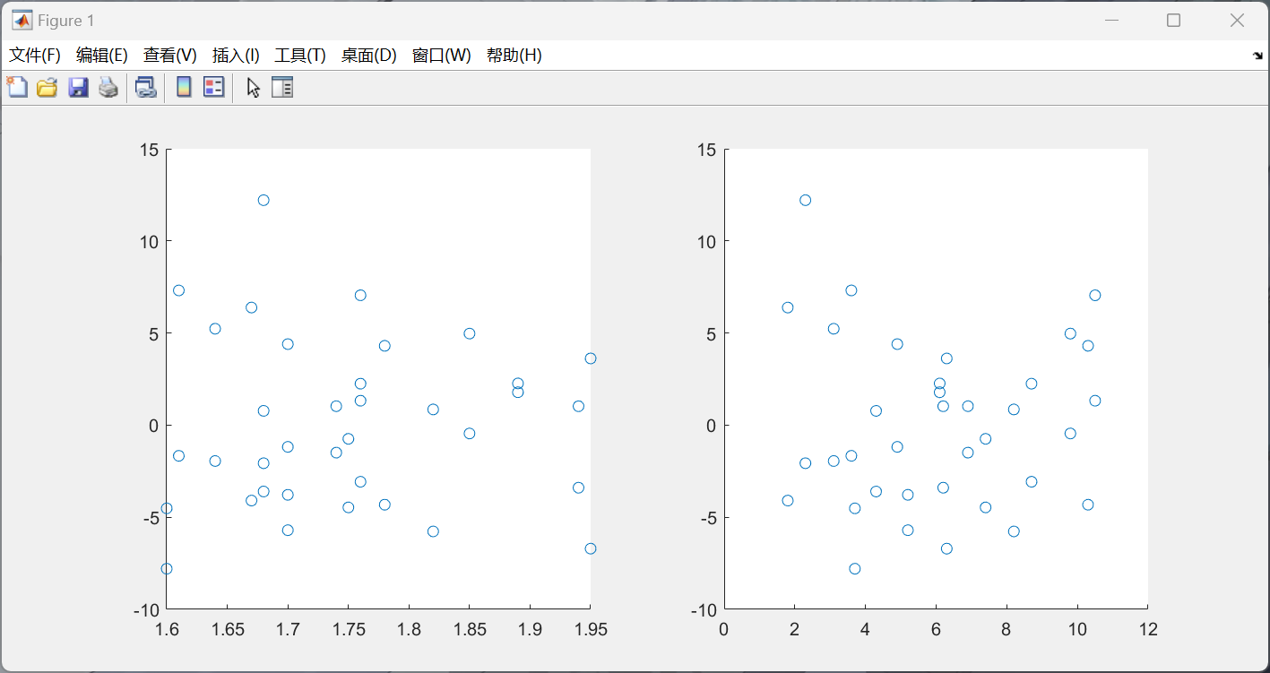
different plots, consider interaction
(4)
b & bint:

-96.3838
175.4603
-3.9657
0.2846
-51.1257
-1.8356
-65.6343
23.0304
1.7923

-531.9949 339.2272
-337.6943 688.6150
-25.4116 17.4801
0.0460 0.5233
-204.5530 102.3016
-15.1728 11.5017
-106.4387 -24.8299
-1.9206 47.9813
0.8216 2.7631

R²: 0.94127 F: 54.0903 s²: 9.6545

